**Practical No.1: Understating Weka and R language**

**Introduction**

* All data mining algorithms are explained with Weka and R language. The learner can perform and apply these algorithms easily using these well-known data mining tool and language.
* Weka is an open-source software under the GNU General Public License System.
* Weka contains tools for data pre-processing, classification, regression, clustering, association rules, and visualization.

**Installing Weka**

* Weka is freely available and its latest version can be easily downloaded from https://www.cs.waikato.
* ac.nz/ml/weka/downloading.html as shown



* To work more smoothly, you must first download and install Java VM before downloading Weka.

**Understanding Fisher’s Iris Flower Dataset**

* R. A. Fisher’s Iris Flower dataset is one of the most well-known datasets in data mining research.
* link <http://archive.ics.uci.edu/ml/datasets/Iris>



* **This dataset contains 50 samples of each of the three species, for a total of 150 samples.**



* **Anderson performed measurements on the three Iris species (i.e., Setosa, Versicolor, and Virginica) using four iris dimensions, namely, Sepal length, Sepal width, Petal length, and Petal width.**
* Hehad observed that species of the flower could be identified on the basis of these four parameters.
* So, he prepared a dataset for its analysis. In data mining terminology, these four iris dimensions are termed as ‘attributes’ or ‘input attributes’.
* The three iris species are known as ‘classes’, or ‘output attributes and each example of an iris is termed as ‘sample’, or ‘instance’ samples, of irises.

**The input attributes are numerical attributes, meaning that the attributes are given as real numbers, in this case in centimeters.**



**Note:**

**The preferred Weka dataset file format is an Attribute Relation File Format (ARFF) format.**

**Weka also accepts several alternative dataset file formats, one of them being the Comma Separated Values (CSV) file format.**

**Understanding ARFF (Attribute Relation File Format)**

**An ARFF file is an ASCII text file that describes a list of instances sharing a set of attributes.**

**ARFF files were developed for use with the Weka machine learning software. ARFF files have**

**two distinct sections. The first section is the Header information, which is followed by the Data**

**information as shown in Figure**



**ARFF header section**

|  |
| --- |
| **The header of the ARFF file contains the name of the relation, a list of the attributes (the columns in the data), and their types. The first line in the ARFF file defines the relation and its format is given as follows.**  **@relation <relation-name>** |

**ARFF data section**

|  |
| --- |
| **The ARFF Data section of the file contains the data declaration line and the actual instance lines. The data declaration line consists of @data statement that is a single line representing the start of the data segment in the ARFF file.**  **The format of the data section of ARFF file is given as follows.**  **@data**  **1.4, 2.3, 1.8, 1.5, ABC** |

**Working with a Dataset in Weka**

**When you start up Weka, you will see the Weka GUI Chooser screen as shown in Figure.**



From Weka Chooser, we can select any of the applications such as Explorer, Experimenter,

Knowledge Flow, Workbench and Simple CLI.

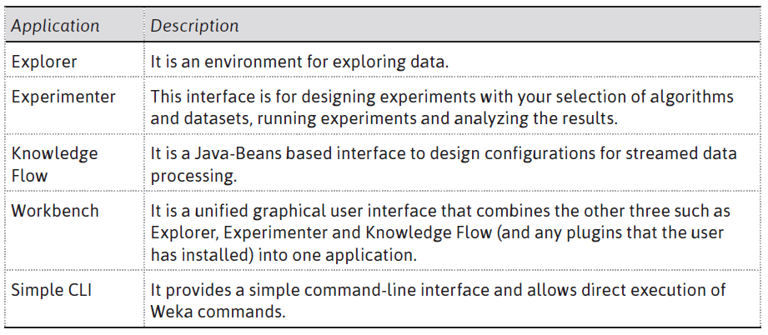



Select the ***Explorer*** application. Selecting the ***Explorer*** application displays the ***Weka Explorer***

screen as shown in Figure 3.8. Select the ***Preprocess*** tab to load the dataset to Weka. On the ***Preprocess*** tab, select ***Open file… and*** then select the ***FishersIrisDataset.csv*** file.

Note that all six attribute columns in our dataset have been recognized, and that all 150 instances have been read as shown in Figure 3.9. For the purpose of analysis, remove the instance number attribute by selecting it in the ***Attributes*** check box, or by clicking on it, as it does not play any role

as shown in Figure 3.9.









**Histogram**

To see a histogram for any attribute, select it in the ***Attributes*** section of the ***Preprocess*** tab.

Figure 3.13 represents the histogram that shows us the distribution of Petal widths for all three

species.





**Histograms for all attributes of Iris dataset [see color plate**



**To practice this concept, let us find distinct and unique values for the following dataset:**

**23, 45, 56, 23, 78, 90, 56, 34, 90**

**Solution:**

**Distinct: 6 (23, 45, 56, 78, 90, 34)**

**Unique: 3 (45, 78, 34)**



**ARFF Viewer**



Note that Weka has identified the Sepal and Petal values as numeric, and species as a nominal

attribute.



**Visualizer**

It is also possible to do data visualization on our dataset from the Weka GUI Chooser. On the GUI

Chooser, choose ***Visualization***, and then ***Plot*** as shown in Figure





**Introduction to R**

* R is a programming language for statistical computing and graphics. It was named R on the basis of the first letter of first name of the two R authors (Robert Gentleman and Ross Ihaka).
* It was developed at the University of Auckland in New Zealand. R is freely available under the GNU General Public License, and pre-compiled binary versions are provided for various operating systems like Linux, Windows and Mac.

**Installing R**

R can be downloaded from one of the mirror sites available at <http://cran.r-project.org/mirrors.html>

After installation of R, the console screen of R will look as shown below in Figure

**Variable Assignment and Output Printing in R**

* In R, a variable name consists of letters, numbers and the dot or underline characters.
* The variable name starts with a letter or the dot not followed by a number.
* The variables can be assigned values using leftward, rightward and equal to operator. The values of the variables can be printed using *print( )* or *cat( )* function. *cat( )* function combines multiple items into a continuous print output as shown in Figure
* 

**Data Types**

* The data type of a variable can be identified using the *class( )* function as shown in Figure
* Here, the variables ***var1*** and ***var3*** represent the data type numeric as we have assigned a numeric value 5 and 23.5 to variable *var1* and *var3* respectively.
* Similarly, ***var2*** represents the data type character as a character string is being assigned to *var2*.



* There are five basic data types in R such as numeric (real or decimal), integer, classic, logical and character.

**Basic Operators in R**

has many operators to carry out different operations and can be classified into the following

categories such as arithmetic, relational, logical and assignment operators.

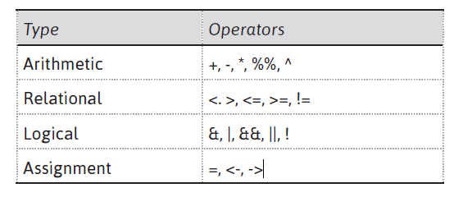



**install.packages(“Package Name”)**

**Loading of Data**

* In R, we can upload the data using any file format such as .xls, .csv or .arff format. For this, we
* can use the function ***read function***

|  |
| --- |
| **>library(gdata) # load gdata package**  **>mydata = read.xls(“mydata.xls”) # read from first sheet**  **Or**  **>mydata = read.csv(“mydata.csv”) # read from csv format**  **Or**  **>mydata = read.arff(“mydata.arff”) # read from arff format** |

**Working with the Iris dataset in R**

* **In R, some of the datasets are available in datasets library. The dataset library is first loaded to include**
* **any dataset of your choice. Then use the command data to load dataset as given below.**

|  |
| --- |
| **>library (datasets) # load datasets package**  **> data (iris) # load dataset**  **> names (iris) # display attribute names** |



|  |
| --- |
| **> summary (iris)**  **> summary (iris$Sepal.Width)** |

The dataset can be viewed using the function ***View( )*** as shown in Figure 3.33. This figure shows

the first 18 records of the iris dataset.

|  |
| --- |
| **> View(iris) #To view the dataset instances** |



We can also find the missing and unique values of an attribute in a dataset by using ***is.na( )*** and

***unique( )*** functions. Figure 3.34 shows that there are 23 unique values for the column Sepal Width

and no missing value.

|  |
| --- |
| **> is.na(iris$Sepal.Width) # To find the missing values**  **>length(unique(iris$Sepal.Width)) #To find the unique values** |



The graph can be plotted for a dataset using the ***plot( )*** function. For example, Figure 3.35 shows

the plotting of Iris dataset in R.

|  |
| --- |
| **> plot(iris) #To plot the graph of complete dataset** |



Similarly, a graph can also be plotted between any two columns using the ***plot( )*** function. For

example, Figure 3.36 shows the graph between columns Petal width and Petal length.

|  |
| --- |
| **> plot(iris$Petal.Width, iris$Petal.Length) #To plot the graph of between any two**  **attributes of dataset** |



|  |
| --- |
| For a given set of training data examples stored in a .CSV file(diabetes.csv) read the data from csv file and divide the data into input attribute and target attribute.(Download diabetes.csv data from internet).  Link to download  **(https://raw.githubusercontent.com/plotly/datasets/master/diabetes.csv)** |
| import pandas as pd dataset = pd.read_csv("diabetes.csv ") print(dataset.head()) x = dataset.iloc[:, [0, 1, 2, 3, 4, 5, 6, 7]].values y = dataset.iloc[:, [-1]].values print(x) print(y) |

|  |
| --- |
| For a given set of training data examples stored in a .CSV file(iris.csv) read the data from csv file and divide the data into input attribute and target attribute.  (Download iris.csv data from internet).  Link to download Data Set  **'https://archive.ics.uci.edu/ml/machine-learning-databases/iris/iris.data'** |
| **import pandas as pd**  names = ["sepal-length", "sepal-width", "petal-length", "petal-width", "class"]  dataset = pd.read_csv('iris.csv', names=names)  # Display dataset  print(dataset.head(10))  X = dataset.drop(["class"], axis="columns")  Y = dataset["class"]  print(X)  print(Y**)** |